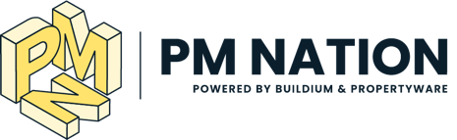

Dear [insert name],

I’m writing to seek approval to attend PM Nation, a 2-day workshop-style conference hosted by Buildium and Propertyware for property management professionals in Boston on November 15 & 16, 2021.

Here are some quick facts about the conference:
- PM Nation is bringing together 500 active property managers and experts for the industry’s most hands-on training event of the year
- With 6 learning tracks and sessions capped at a small size, this event will offer real-world, tactical, hands-on learning unlike any other conference in the industry.
- I will learn from recognizable industry experts and technology specialists who will be sharing tried-and-true best practices, current trends, latest strategies, case studies, new technologies, and more.

Based on the agenda, I see clear ties to our work at [insert your company name]. Our organization is currently highly focused on [insert company priorities]. At PM Nation, topics will cover a broad spectrum, but the following tracks particularly appeal to me and our needs: [choose which tracks to list: “Better Books, Better Business”, “Profitability & Growth”, “Resident Experience,” “Become a Communications Master,” “Data + Insights = Power,” and “they even have a “Wild Card” track that will cover some of the newest topics in the industry”].

[If you’re a Buildium or Propertyware User]
Also, since this event is being hosted by Buildium and Propertyware, I will get direct access to their trainers and will be able to set one-on-one appointments to learn more about the platforms or resolve any issues we have. All tracks will have platform-specific sessions associated with the category and the hands-on workshop style will guarantee that I leave with new ways to navigate and efficiently use our account.

[If you’re not yet a Buildium or Propertyware User]
While I'm there, I will make the most of the direct access to Buildium and Propertyware’s team and perhaps set one-on-one appointments with their specialists. It's a good opportunity to learn more about the platform and evaluate whether it could be a good fit for our business.

Here is an outline of the investment: [fill in costs yourself]

Travel: $XXX
Hotel (3 nights): $XXX
Registration Fee (including some meals): $XXX
Misc.: $XXX
Total: $XXX

Thank you, and I look forward to the opportunity to attend PM Nation!
[insert your name]

